️**Capstone Project Report: Big Mountain Resort**

**Introduction**

Big Mountain Resort wants to adjust ticket prices to increase revenue while keeping guests happy. Current tickets are $81, below the market value. The goal was to find the key factors influencing price and recommend an updated ticket rate.

**Problem Statement**

Design a pricing strategy that reflects the resort’s value, especially with upcoming upgrades like a new chair lift, aiming to maximize revenue without reducing demand.

**Data Preparation**

* Cleaned data: filled missing values, removed duplicates
* Standardized formats and combined resort features, pricing, and cost data
* Created a reliable dataset for analysis

**Exploratory Analysis**

* Tickets are undervalued at $81
* Key price drivers: vertical drop, number of runs, snowmaking
* Peak-season pricing could further boost revenue

**Modeling**

* Tested Linear Regression and Random Forest models
* Random Forest performed best, capturing complex relationships

**Findings & Recommendations**

* Optimal ticket price: **$94** without hurting demand
* New chair lift adds ~$2 per ticket, still profitable
* Planned upgrades support higher pricing
* **Recommendation:** Raise tickets from $81 → $94

**Conclusion**

Big Mountain Resort can increase prices safely, better reflecting its value and supporting future growth.

**Next Steps**

* Analyze costs for profitability
* Consider customer segmentation for dynamic pricing
* Build a dashboard for scenario testing
* Update models regularly to track market trends

FIGURES -

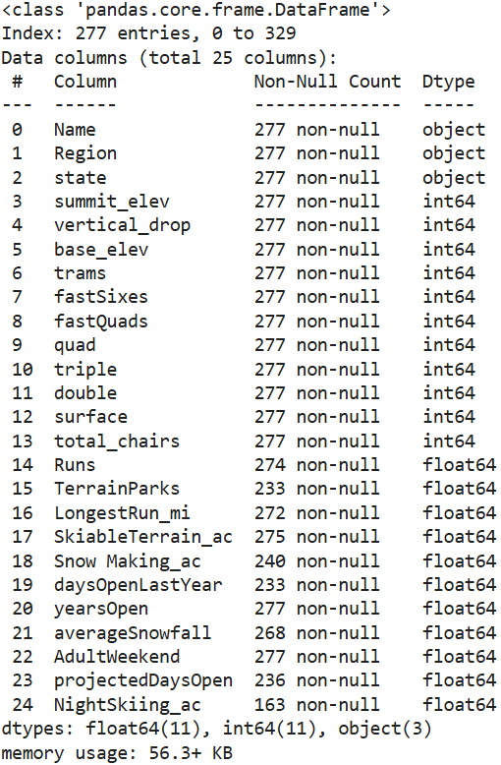

Fig1 - Data Cleaning Overview

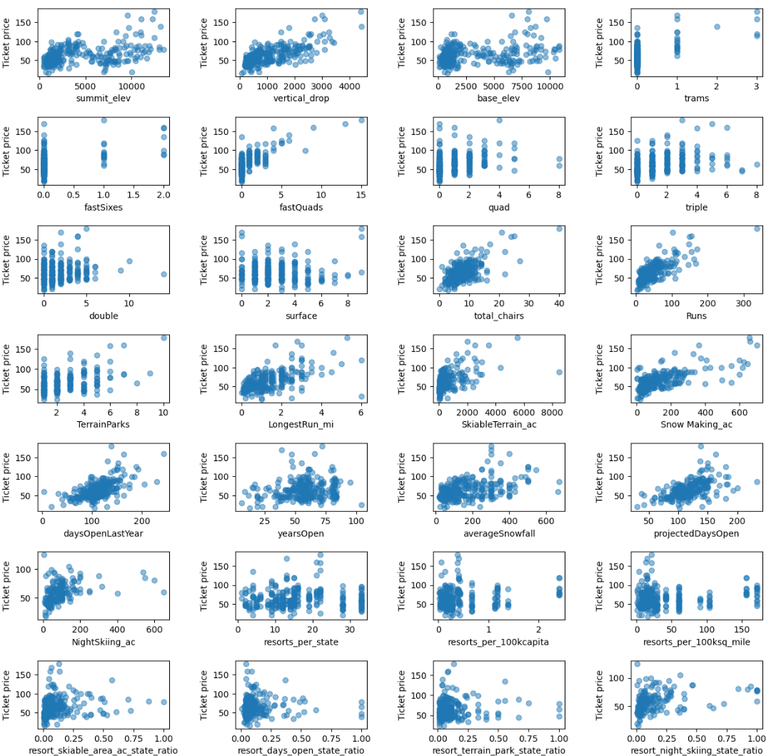

Fig2- Price vs Facility Features

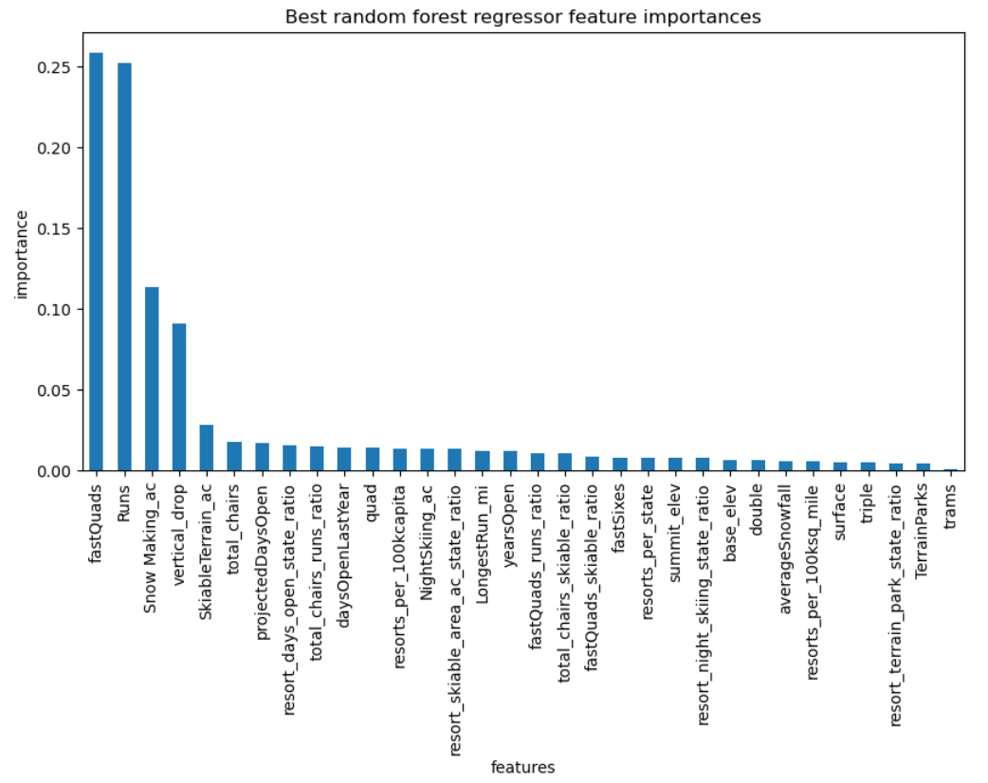

Fig3 – Feature Engineering Process.

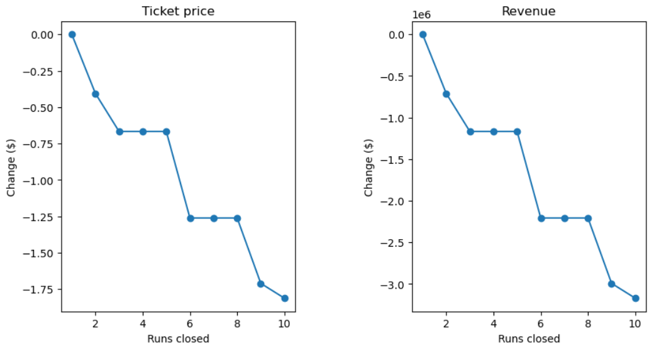

Fig4 – Model Performance Comparison